**User Guide for Kanban Board**

*Main page*



*Board view*

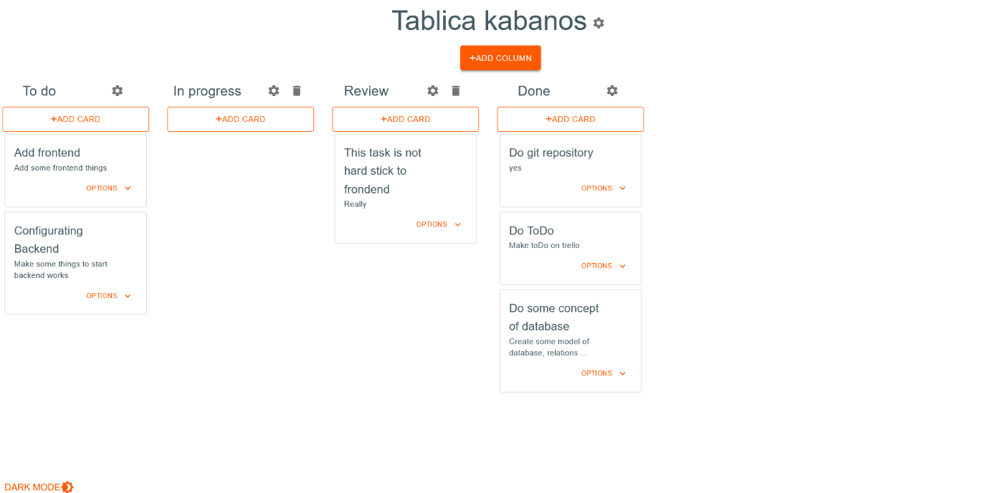

You start on the home page. To go to the Kanban board, click the login button. You have been moved to the board. The newly created board has 3 columns, the middle one has a limit of 3 cards.

To change to a dark theme, click on the word "DARK MODE" in the upper right corner of the page.

1. Board-related functionalities:

* Changing the table title:   
  To change the board title, click the gear wheel next to the board title. In the window that appears, enter a new title and confirm it.

1. Functionalities related to the column:

* Adding a column:

To add a column, press the "ADD COLUMN" button and enter the column name. The standard limit of cards in a column is 3.

* Changing the column title:   
  To change the column title, click the gear wheel next to the column title. In the window that appears, enter a new title and confirm it.
* Changing the cards limit for a column:   
  To change the cards limit for a column, click the gear wheel next to the column title. In the window that appears, enter a new card limit or select unlimited.
* Moving a column:   
  To move a column, click and hold the column you want to move, then move it to a new position.
* Deleting a column:   
  To delete a column, click on the trashcan icon and confirm the deletion in the pop-up window. When deleting a column, all cards assigned to it will also be deleted.

1. Functionalities related to the card:

* Adding a card:   
  To add a card, press the "ADD CARD" button above the column to which you want to add a card and enter the name of the card as well as its description. The card will appear at the bottom of the column.
* Changing the title of the card:   
  To change the card title, click "OPTIONS" in the lower right corner of the card you want to edit. In the window that appears, select "Edit" and in the next window, edit the title.
* Changing the description of the card:   
  To change the card's description, click "OPTIONS" in the bottom right corner of the card you want to edit. In the window that appears, select "Edit" and in the next window, edit the description.
* Moving the card:   
  To move a card, click and hold on the card you want to move, then move it to a new position in the same column, or move it to a new position in a different column.
* Delete card:   
  To remove a card, click "OPTIONS" in the lower right corner of the card you want to remove. In the window that appeared, select "Delete" and confirm the deletion in the pop-up window.